Executive Summary
6/22/2023

INTRODUCTION
The Southwestern Pennsylvania ITS Architecture has been updated from the 2016 version by the Southwestern Pennsylvania Commission (SPC). This is in accordance with the FHWA CFR 940.9 regulations and the corresponding FTA policy. The Southwestern Pennsylvania ITS Architecture is based on the United States National ITS Architecture, also called ARC-IT (Architecture Reference for Cooperative and Intelligent Transportation). This executive summary provides a brief overview of what this ITS architecture is and why it is important.

This Regional ITS Architecture is a roadmap for transportation systems integration. The architecture was developed through a cooperative effort by the region's transportation agencies, covering all modes and all roads in the region. It represents a shared vision of how each agency's systems will work together in the future, sharing information and resources to provide a safer, more efficient, and more effective transportation system for travelers in the region.
The architecture provides an overarching framework that spans all of the region's transportation organizations and individual transportation projects. Using the architecture, each transportation project can be viewed as an element of the overall transportation system, providing visibility into the relationship between individual transportation projects and ways to cost–effectively build an integrated transportation system over time.
The purpose of the regional ITS architecture web site https://local.iteris.com/spc/index.htm is to encourage use of the regional ITS architecture and gather feedback so that the architecture is used and continues to reflect the intelligent transportation system vision for the Southwestern Pennsylvania region.
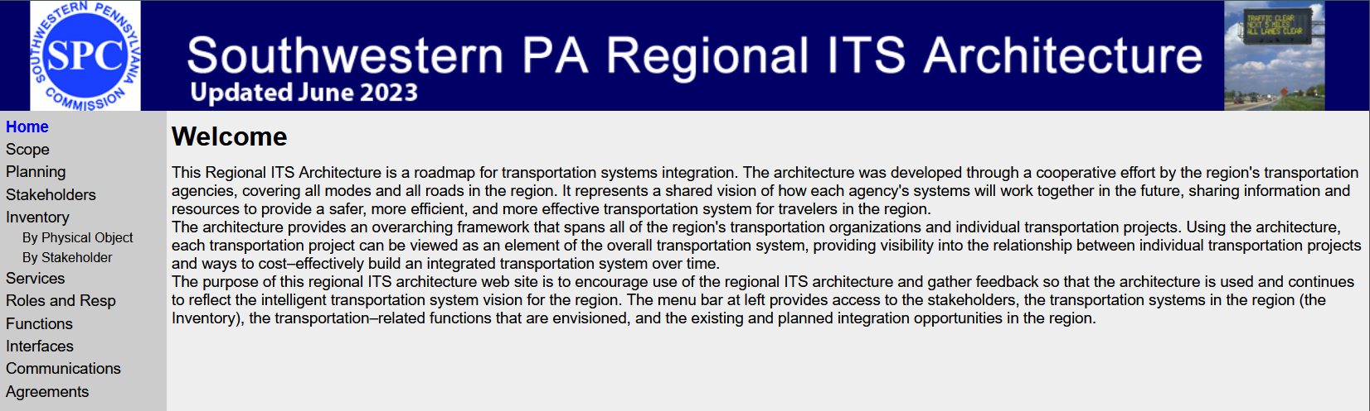
The menu bar on the left side of the website provides access to the stakeholders, the transportation systems in the region (the Inventory), the transportation–related functions that are envisioned, and the existing and planned integration opportunities in the region.

The goal of the SW PA Architecture Website is to provide users with access to the architecture content in the many forms it is represented in the architecture definition. This is easily accomplished with tools available today.

